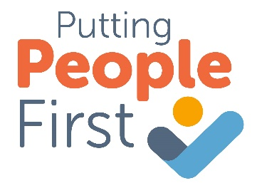
Community Appointment Day – Self Assessment 1

Based on the Essential Ingredients from HERE

Personalise and humanise | - Remove hurdles to humanity: Take away barriers to human and unhurried care: time constraints, appointment slots, bureaucracy, and physical doors.  - See the whole person: Understanding someone’s condition and health in the wider context of their life and supporting from this lens.  - Understand what really matters: Front-ended and highly skilled What Matters To You (WMTY) conversations are the key to unlock everything which follows
Remove hurdles to humanity | What are we doing to remove hurdles to humanity from the points above?
See the whole person | What are we doing to see the whole person from the points above?
Understand what really matters | What are we doing to understand what really matters from the points above?
Further ideas | What else can we do to personalise and humanise this CAD?
Our learning | What is our learning from this? Are there any ideas for action in CADs or in wider services?
Power, participation and connection | - Conversation not consultation: De-medicalise the interaction between people, the content of what is said and the environment.  - Explicitly community-powered: Grow conditions for participation in care which is asset-based, engage with the passion and skill of the community and voluntary sector.  - Let go of ego: Honour the expertise of people seeking care as much as those providing it
Conversation not consultation | What are we doing to promote conversation not consultation from the points above?
Explicitly community-powered | What are we doing to ensure the CAD is explicitly community-powered from the points above?
Let go of ego | What are we doing to let go of ego?
Further ideas | What else can we do to promote power, participation and connection?
Our learning | What is our learning from this? Are there any ideas for action in CADs or in wider services?
Purpose-led design | - Data led: Deeply understand the population, who is accessing services and their experiences, who is not and the barriers to equitable care. Demonstrate impact.  - Local flavour: Tailor delivery to the local population, tapping into the vibrant community roots.  - Everyone culture: Care includes colleagues, create purposeful opportunities to nurture, connect, and develop.
Data led | What are we doing to be data led from the points above?
Local flavour | What are we doing to ensure local flavour from the points above?
Everyone culture | What are we doing to promote an everyone culture from the points above?
Further ideas | What else can we do to be purpose-led in the design of this CAD?
Our learning | What is our learning from this? Are there any ideas for action in CADs or in wider services
Underpinning approach: | Listen and consult | Clear and devolved decision making | Comfort in failing fast | Capture learning
After the first CAD, we should review these essential ingredients. Use feedback from staff, stakeholders and service users to guide what we should change in our essential ingredients.

Ensure these essential ingredients are captured in the monitoring and evaluation of the CAD

