- Here to support and empower staff to maintain skin integrity and manage skin damage.  Our aim  To prevent avoidable skin damage to any individual in NHS Grampian.  To ensure patients receive prompt, evidence-based care.  To ensure staff receive updates and are educated in prevention and management of skin damage.  - Contact us  All patient referrals and related queries should be sent to:  gram.tissueviabilityacute@nhs.scot  for NHSG acute, Orkney & Shetland  gram.tissueviability@nhs.scot for primary care and care homes. | Tissue Viability Service  (Please note that our service is fully electronic)  Team  Acute:  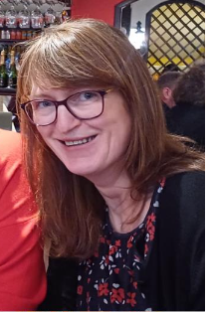      Ines Pereira Kate Watson Kristine Duguid  (Also part of the Aberdeen city team)  Aberdeen city:  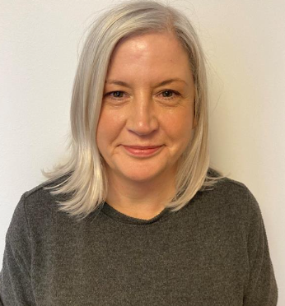  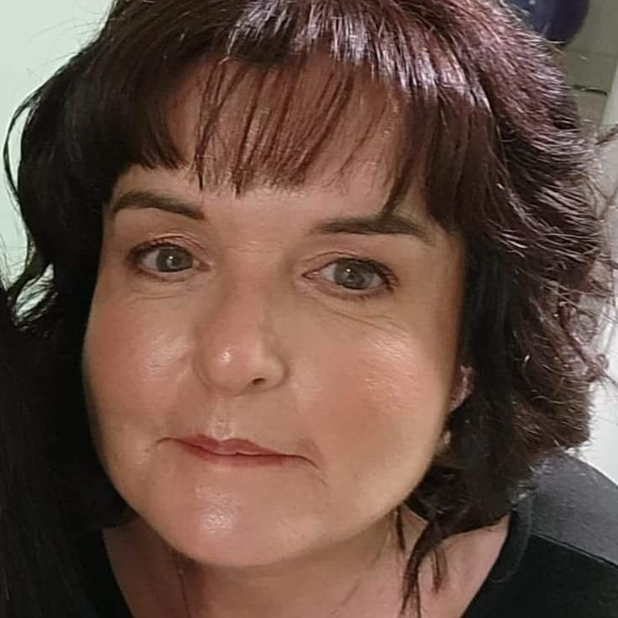  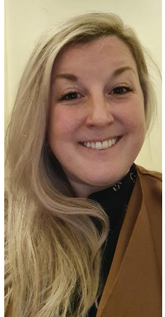  Kayren Baker Laura McAulay Lynsey McIntosh  Aberdeenshire:  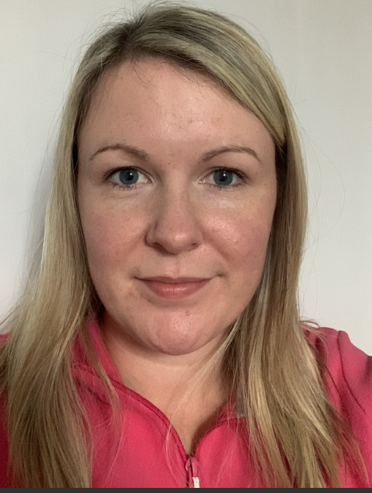  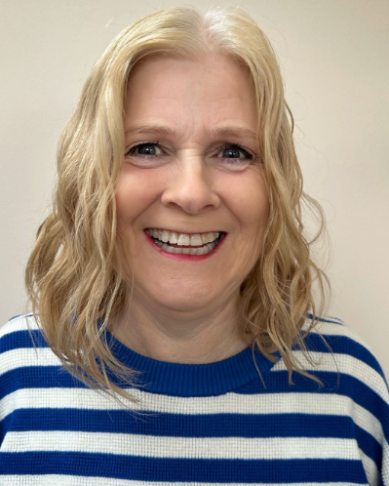  Elaine Stirton Rebekah O’Hara  Moray:  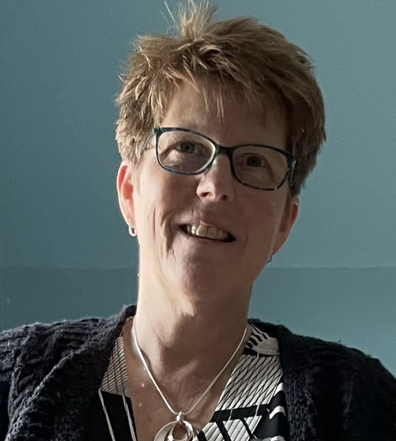  Ally Lister  All documents can be accessed via NHS Grampian Guidance (8c,8d) or Hi - net Grampian.  Service related information, policies, educational resources, etc. and Team’s information can be accessed via the Departments section on the NHSG intranet page.  Referral form  Please use the referral form: e-clinic referral form  This is also available on Hi - net Grampian for tertiary care.  Education request form  Please use the request form to help our team to triage education sessions, by highlighting your education needs:  Request form - Also available on Hi - net for tertiary care.  gram.hinet@nhs.scot  Please send it to: gram.tissueviabilityeducation@nhs.scot and the team will be in contact to discuss your teams’ needs.  If you have any suggestions, concerns related to the Tissue Viability Service, please contact the Nurse Consultant - Ines Pereira: ines.pereira@nhs.scot

