4TH OCTOBER 2023
Thainstone House hotel
NHS Grampian Managed Clinical Network (MCN) Oral and Dental Health Conference Pack

Thank you for attending this event. We hope you enjoyed the day and found the presentations varied and interesting. We also hope that you gained more than just the learning outcomes, through the networking opportunity and sharing of ideas and knowledge between colleagues, new and old.
In this pack you will find information about all the presentations from the conference, such as contact details and useful links. You will find the full presentations themselves separately on the HI-Net page. This document also has a copy of the posters displayed, and the presenter biographies. To skip to a certain section, simply click the links in the index list below.
INDEX
Aims, objectives and learning outcomes
Presentations:
1: Promoting Lifelong Smiles: A whistle stop tour of Oral Health Improvement through the Life Stages
2: Communicating with the Anxious Patient
3: Dental Management of Patients with Haematological Malignancy
4: A Team Approach to Child Dental Trauma
5: Practice Manager
6: OMFS / OS Pathway
Additional Slides
Posters:
Introducing the Palliative Oral Care Box in the Care Home Setting
Decider Skills in the Word of Oral and Dental Health
Improving Access to Dental Registration
Variations to methods adopted during Fluoride Varnish sessions
Shared Care: What, When Why and How?
Overview of an Undergraduate Special Care Dentistry Course
Presenter biographies

Aims and Objectives for the conference

Learning Outcomes for the conference

Presentation 1:
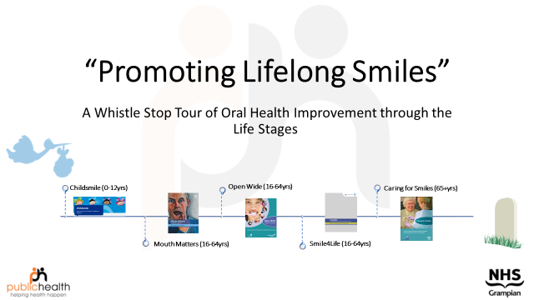
Full presentation: See pdf files accompanying this pack.

Key messages -
- There is a wide range of Oral Health Improvement programmes to support individuals throughout the Life Stages
- There are many opportunities for working in partnership with local OHI teams to help improve the dental and oral health of our Grampian population
- There are many opportunities for Dentists and DCPs to contribute to OHI throughout the Life Stages

Links

Childsmile (Children)
Caring for Smiles (Older people)
Open Wide (Adults with additional needs - cognitive, physical, medical)
Smiles 4 Life (Homeless population)
Mouth Matters (Prison population)

Contact details:
Gwen Robertson, Advanced Public Health Practitioner (Dental and Oral Health, Grampian Wide) - gwen.robertson@nhs.scot

Childsmile Co-ordinators -
Aberdeen City – Pippa Robbie: pippa.robbie@nhs.scot
Aberdeenshire – Michelle Whyte: michelle.whyte@nhs.scot
Moray – Sarah Gourley: sarah.gourley@nhs.scot

Oral Health Improvement Team Leaders (Priority Groups) -
Aberdeen City – Rebecca Jacobs, Shirley Beattie, Jackie Park gram.cityohpteamleaders@nhs.scot
Aberdeenshire – Diane Lawson: diane.lawson1@nhs.scot
Moray – Sarah Gourley: sarah.gourley@nhs.scot

Thank you to those who contributed to the short exercise during our presentation.
We asked the question - 'What part can you and your team play in supporting some of these programmes?'
The main themes that became apparent were -
- Increasing awareness of the programmes within the work environment as well as with patients
- Ensuring good communications with the local Oral Health Improvement teams (this includes Childsmile)
- Reinforce/share consistent messages
- More partnership working between dentists/OHI teams and care homes/appropriate agencies
- Intervention at the right time with the vulnerable groups
You will find the links above to each of the different Oral Health Improvement programmes for your reference.

Presentation 2:
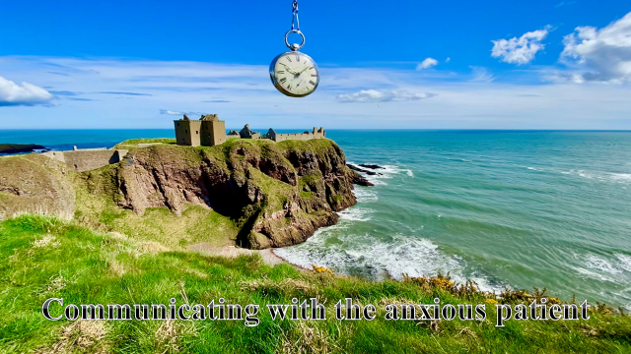
Full presentation: See pdf files accompanying this pack.

Links:
ISDAM- www.isdam.com – Membership available. Mixture of workshops and presentations at conferences. Advanced Hypnosis Modules launching soon.
HYPNOSIS:
BSMDH SCOTLAND - www.bsmdhscotland.com
BSCAH- www.bscah.com
RSM SECTION ON PSYCHOSOMATIC MEDICINE
& HYPNOSIS- www.rsm.ac.uk/academ/sech_p.php
SEDATION:
SAAD – www.saad.org
SCOTTISH SEDATION TRAINING- www.scottishsedationtraining.co.uk
DENTAL SEDATION TRAINING GROUP- www.dstg.co.uk
UKSEDATION: www.uksedation.com
MELLOW DENTAL – www.mellowdental.co.uk
YORKSHIRE SEDATION TRAINING - www.yorkshiresedationtraining.co.uk
MANCHESTER SEDATION COURSES- www.mansedcourse.com
Education:
Postgraduate Certificate in Dental Sedation and Anxiety Management (Uni of Edin) – POSTPONED – www.ed.ac.uk/dentistry/online-learning/postgraduate-certificate-in-dental-sedation
Dental Sedation and Pain Management (UCL) – www.ucl.ac.uk/eastman/study/dental-sedation-pain-management
Conscious Sedation in Dentistry PGDip (Newcastle Uni) - www.ncl.ac.uk/postgraduate/courses/degrees/conscious-sedation-in-dentistry-pgdip/#profile
Postgraduate Certificate Clinical Conscious Sedation and Anxiety Management (Uni of Bristol)- www.Bristol.ac.uk/dental/courses/postgraduate/conscious-sedation-anxiety-management

Contact details:
Mike Gow: mike@berkeleyclinic.com
Instagram, X and TikTok: @drmikegow
Facebook: @dentalanxiety

Presentation 3:
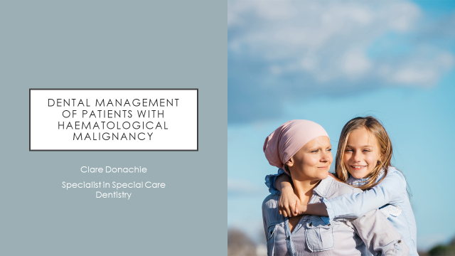
Full presentation: See pdf files accompanying this pack.
Learning Outcomes
- Assess dental needs of patients with haematological malignancy
- Collaborate effectively as part of a professional team
- Apply principles to optimise care for these patients

Contact details:
gram.dentalspecialcare@nhs.scot
gram.haemcns@nhs.scot
Clare Donachie: Claire.donachie@nhs.scot
Iain Bovaird, Senior Dental Officer, Special Care Dentistry: Iain.bovaird@nhs.scot
Lois Gall, Senior Dental Officer, Special Care Dentistry: Lois.gall@nhs.scot

Additional information
A slide show presentation for Dental assessment of Cardiothoracic Surgery and Haematological Malignancy Patients, by Becky Lees, SDO Oral Surgery: See pdf files accompanying this pack.

Presentation 4:
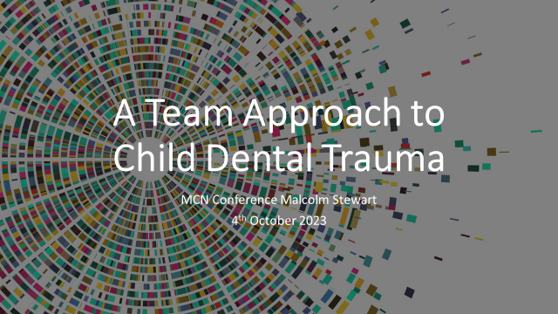
Full presentation: See pdf files accompanying this pack.

Contact details:
DARC gram.pcdreferralhub@nhs.scot
Dental Institute gram.dentalinstitute@nhs.scot
Malcolm Stewart: Malcolm.stewart@abdn.ac.uk

Presentation 5:
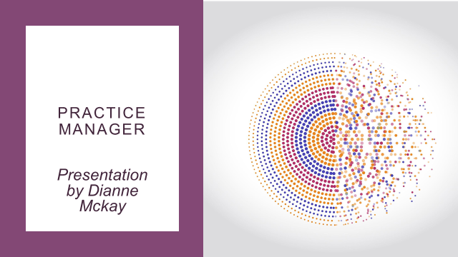
Full presentation: See pdf files accompanying this pack.
Contact details:
dianne@turriffdentalcare.co.uk

Presentation 6:
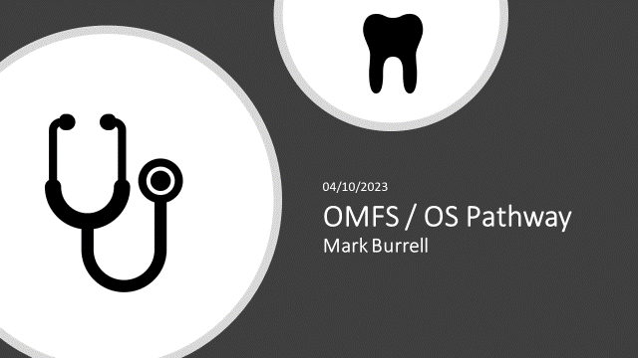
Full presentation: See pdf files accompanying this pack.

Aims
- To explain where Minor Oral Surgery (MOS) fits into the ‘Shared Care’ model
- Guidance Documents available; information and ‘toolkit’ required to provide care in your own surgery.
- To introduce professional team members in Grampian who will be able to support the delivery of ‘Shared Care’

Objectives
- To introduce members of the Minor Oral Surgery Team in Grampian
- To recognise when an extraction / MOS procedure is the most appropriate option for a patient based on a treatment plan which respects the medical history (past, current and ongoing care) and any transitional P/P to F/F provision.
- To list available Dental Clinical Guidance related to Bisphosphonates and Anticoagulants and outline advice which may be available from GMPs, Community Pharmacists and other specialties.
- To recognise investigations required to assess the difficulty of an extraction and how to arrange these if unavailable in own setting.
- To have equipment and medicaments available to make a patient comfortable In the event of a failed extraction in order to avoid the need for an emergency referral.
- To introduce the appropriate use of Photographs, ‘Near Me’ and the MOS Referral Pathway

Links:
Radiology Pathway: https://www.hi-netgrampian.org/wp-content/uploads/2021/06/Radiology-pathway.pdf
FAQ document: https://www.hi-netgrampian.scot.nhs.uk/wp-content/uploads/2021/06/Combined-Oral-Surgery-and-Oral-Maxillofacial-Service-3.pdf
TURAS: Active Clinical Referral Triage (ACRT) | Turas | Learn (nhs.scot)
Other Links:
https://scottish.sharepoint.com/sites/GRAM-Guidance.
https://scottish.sharepoint.com/sites/GRAM-Guidance/SitePages/Maxillofacial-Surgery.aspx
https://www.hi-netgrampian.scot.nhs.uk/wp-content/uploads/2022/02/Oral-and-Maxillofacial-and-Oral-Surgery-22.pdf
https://www.hi-netgrampian.scot.nhs.uk/wp-content/uploads/2022/02/Combined-Oral-Surgery-and-Oral-Maxillofacial-Service-22.pdf

Contact details:
mark.burrell@grampian.nhs.scot

Additional Slides
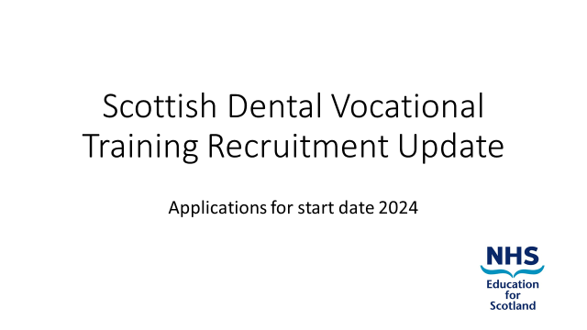
Full presentation: See pdf files accompanying this pack.

Links:
https://www.nes.scot.nhs.uk/media/uuilw2t3/becoming-a-vocational-trainer-booklet.pdf

https://www.nes.scot.nhs.uk/our-work/dental-vocational-foundation-training/

Contact details:
calum.cassie@nhs.scot
William.Cameron@nhs.scot

Request for mouth cancer success stories

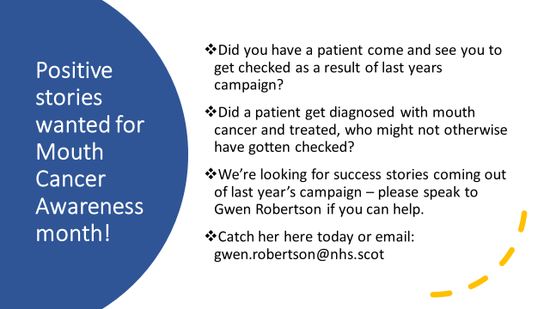

Introducing the Palliative Oral Care Box in the Care Home Setting

Author: Helle Buch Larsen, Public Health Practitioner
Contact: helle.buchlarsen@nhs.scot
Decider Skills in the Word of Oral and Dental Health

Author: Gwen Roberson, Advanced Public Health Practitioner (Dental and Oral Health), with contributions from Kerry Hoobs, Senior Dental Officer.
Contact: gwen.robertson@grampian.nhs.scot
Improving Access to Dental Registration

Author: Lisa Convery, Dental Nurse Team Manager, Unscheduled Dental Care Service
Contact: lisa.convery@grampian.nhs.scot
Variations to methods adopted during Fluoride Varnish sessions

Author: Sarah Gourley, Childsmile/OHI Coordinator, Moray Public Dental Services
Contact: sarah.gourley@grampian.nhs.scot
Shared Care: What, When Why and How?
Author: Iain Bovaird, Senior Dental Officer (Special Care), Clinical Lead Grampian Oral and Dental Health Managed clinical Network
Contact: iain.bovaird@nhs.scot
Overview of an Undergraduate Special Care Dentistry Course
Author: Dr Lois Gall, Senior Clinical Lecturer Institute of Dentistry, University of Aberdeen
Contact: lois.gall@nhs.scot
Presenter Biographies

Mike Alan Gow MFDS RCPS (Gla) BDS (Gla) MSc Hyp (Lon) PGCert (Edin) FCGDent FBSMDH
Email: mike@berkeleyclinic.com
Mike is a general dental practitioner working in private practice at ‘The Berkeley Clinic’ in Glasgow where he has a special interest in dental anxiety management and hypnosis. He graduated from the University of Glasgow dental school in 1999 and undertook formal hypnosis training with the British Society of Medical and Dental Hypnosis (BSMDH) soon after. By 2005, he had a Masters in Hypnosis Applied to Dentistry (Lon) having achieved a 'distinction' in his Diploma year. Mike has a Postgraduate Certificate in 'The Management of Anxious Patients' from the University of Edinburgh. He is a Past President (2008-10, 2014-16) of “The BSMDH (Scotland)” and holds the European Society of Hypnosis Certificate. He has trained as an NLP Practitioner and has undertaken a course in CBT at Kings College London. (He also has an SVQ Diploma in Single Malt Whisky!)
Mike has published many articles, case studies and book chapters on hypnosis and dental anxiety management and has appeared on TV several times (including BBC’s Horizon) demonstrating the use of hypnosis in dental pain control. He has also appeared on ‘Tony Robinson's History of Britain’ to talk about the history of dentistry. He is Chairman of ‘The Henry Noble History of Dentistry Research Group’.

Gwen Robertson (MSc, BSc (Hons), PG Cert CBT)
Email: gwen.robertson@nhs.scot
Gwen is an Advanced Public Health Practitioner currently working within the NHS Grampian Public Dental and Oral Health Team, since October 2022. She has a background in Mental Health Nursing (around 20 years) including practising as a CBT Therapist. She is also an Authorised Decider Skills Trainer and has taught across Scotland including the Outer Hebrides. With a change of career path in mind, Gwen graduated with a Masters in Global Health and Management from the University of Aberdeen in 2017 and moved into the field of Public Health working within Aberdeen City and Aberdeenshire Health and Social Care Partnership Public Health teams, as well as within Aberdeenshire Council as a Health Improvement Officer for Education.

Jackie Park RDN, MDTFEd
Email: jackie.park2@nhs.scot
Jackie has worked as part of the Dental Team for NHS Grampian since 1989, initially as a Dental Nurse within the then Community Dental Service, then after qualifying as an Oral Health educator, as an Oral Health Team Leader as part of Aberdeen Cities Public Dental Service. Her role focuses mainly on reducing the oral health inequalities amongst identified priority groups through the delivery of both National and Local initiatives. Jackie also works for NHS Education for Scotland as a Dental Tutor supporting the delivery of qualifications to Dental Nurses at both Pre and Post Registration level. In addition, she is also a Member of the Faculty of Dental Trainers RCSED.

Dianne McKay

Email: Dianne@turriffdentalcare.co.uk

Hi my name is Dianne Mckay and I have worked in the field of dentistry for the last 30 years. I have seen lots of changes over time - from beginning when I was a Trainee Dental Nurse on the YTS scheme, working my way up, till now as a Practice Manager.
My path has been experienced based and varied, as I have worked for a solo practitioner and also have been part of a 6 practice group.
Working up through the ranks from Trainee to Qualified Dental Nurse, Head Nurse and now Practice Manager has given me great insight to how the business runs from all aspects of the job.
I have enjoyed working with both NHS and Private patients and also had experience of assisting in Implants and Surgical Procedures.
I am amazed at the leaps forward dentistry is taking and love to see the new advances taking place.
I still get to occasionally use my nursing skills and even after all these years, working on the front line with the patients is a part that I really enjoy!

Mark Burrell
Email: mark.burrell@nhs.scot
Following graduation from Dundee University in 1991 I worked in Dundee, the Northwest of England and finally I took up a position in Grampian in 1994 as a senior house officer in oral and maxillofacial surgery. Since 1997 I have been a staff grade and now a specialty doctor in oral maxillofacial surgery concentrating mainly on delivery of dentoalveolar surgical treatment. My main interests are in paediatric oral surgery and implantology.
I have recently moved into a more managerial role being clinical lead of oral and maxillofacial surgery from March 2020 to August 2022 when I took up the role of Service Clinical Director of oral and maxillofacial surgery and the Institute of Dentistry.
As chair of the Area Dental Committee, I now sit as Chair of the Area Clinical Forum and I am non- executive director on NHS Grampian board.
Pathways of health care now form a significant part of our service delivery plan and I provide the governance framework around this.
Outside work, my interests include dog walking, forestry, car maintenance/restoration and most importantly holidays with my better half Catriona!

