# Scotland’s Service Directory

Scotland’s Service Directory (or SSD for short) is now available on the NHS Inform website: [www.nhsinform.scot](http://www.nhsinform.scot)

You’re now able to search for a wide range of services, from A&Es to Sexual Health Services. It is probably most useful when searching for services that don’t necessarily fit into the NHS model, NHS Inform have called these ‘Health & wellbeing’ services. There may be a huge number of such services depending on where the user is located, any of which might be useful for a patient or carer to engage with.

There are two ways of searching the SSD on the Inform homepage. You can either use the search bar at the top of the homepage:



or you can use the SSD ‘plug in’ hosted elsewhere on the homepage:

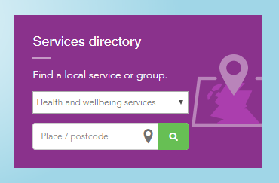

Using the plug in you need to immediately refine your search with a postcode. Search ‘health &wellbeing services’ and you will be presented with a list similar to this:

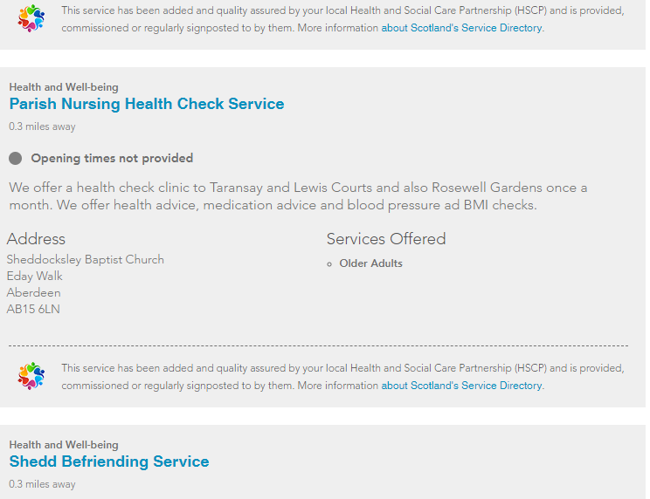

You can then refine your search:

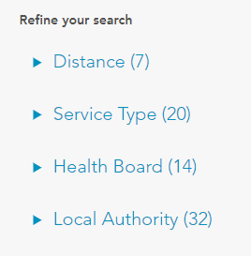

Services are labelled in one of four ways:









Service information on the SSD is placed directly on it by staff working nationally or locally in the NHS or Health & Social Care Partnerships. This information is updated every six months, sometimes more often than that.

Information can also be added by the public and other private or charitable service providers via the ALISS database. Note the information can be claimed or unclaimed. If claimed the service is in charge of their own information and this is more likely to be accurate than unclaimed information which has been uploaded by a third party.

As a relatively new system some service information is lacking but information is being added every week.

The Directory is portable and can be added to other websites. It will be added to NHS Grampian’s public website soon, along with new GP website templates being supported by NHS Inform.