 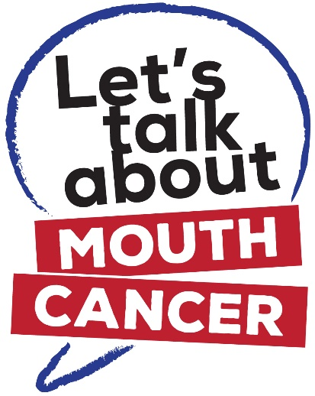 

**NHS Grampian’s Mouth Cancer Campaign**

In the UK more than 7,700 people are diagnosed with mouth cancer every year – that’s 21 people every day. 2,386 people died from mouth cancer in 2014, up by 21%. It is one of the few cancers on the rise – especially in younger adults - and it still claims more lives than cervical and testicular cancer combined.

Sadly, survival rate at 5 years is only 56%, as the majority of cases are only detected at a late stage. With early detection and diagnosis, survival rate increases to more than 90%.

During 2019/2020 NHS Grampian is running the **Let’s Talk about Mouth Cancer** campaign to raise awareness of mouth cancer and the importance of checking your mouth. Watch out for our social media campaign which includes a video urging the public to check their mouths and also a 2 minute video showing how easy it is to do it.

**How the GP Practice team can help**

Please help support the Let’s Talk about Mouth Cancer campaign by:

1. Displaying the enclosed posters and leaflets in your waiting room / reception area.
2. Playing the Mouth Cancer Check video on waiting room screens (found at [www.LTAMC.org](http://www.LTAMC.org)) <https://www.youtube.com/watch?v=qjJichWvTFk>
3. Engaging patients in conversation about the risk factors associated with mouth cancer (i.e. reducing smoking and drinking)
4. Providing patients with supportive information, for example, leaflets covering the topics of smoking cessation and sensible drinking (available through the Resources Service below)
5. Referring patients in if you have any cause for concern.

**Please note, additional leaflets and posters can be ordered free of charge from NHS Grampian’s Health Information Resources Service by telephoning 01224 558504 or online by visiting** [**http://www.nhsghpcat.org/HPAC/Index.jsp**](http://www.nhsghpcat.org/HPAC/Index.jsp)**.**

If you require any further information about mouth cancer or the campaign, please visit [www.LTAMC.org](http://www.LTAMC.org) or contact Karen Tosh by email at [k.tosh@nhs.net](mailto:k.tosh@nhs.net) or telephone 01224 558524.