**Grampian Oral & Dental Health Managed Clinical Network (MCN) Newsletter**

ISSUE 3 – October 2019

|  |  |
| --- | --- |
| **Contents**  Meet the Team - 1  Dental Reference Guidance – update - 2  NHS Health Scotland Very Brief Advice on Smoking eLearning Resource - 2 | Modern Apprenticeship in Dental Nursing – 3  Peer review and Quality Improvement - 4  MCN Annual Report 2018/19 - 4 |

**Meet the Team - Helle Buch-Larsen, Public Health Practitioner**

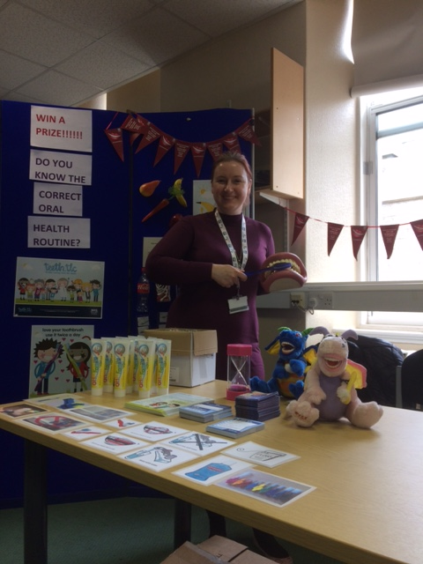After more than nine years working on Childsmile evaluation, I was very happy to take up the post of Public Health Practitioner in May. This has so far proved to be a very varied and more collaborative role.

My focus is on oral health and, as I sit within the wider public health team, I have the opportunity to work closely with other public health colleagues and help keep oral health on their radar.

My main pieces of work currently include the creation of the new Teen TLC website and assisting Cfine with setting up their new [Best Start and Smile Pantry](https://www.cfine.org/news/cfine-awarded-oral-health-funding). I have so far also attended a couple of NHS staff health events with my oral health stand.

My wider role is to support and assist with a variety of health improvement programmes and projects, which includes the ‘[Let’s Talk About Mouth Cancer](https://www.ltamc.org/)’ campaign and the [Tobacco-free Charter](https://www.ashscotland.org.uk/charter) initiative from Ash Scotland.

I also support the Oral and Dental Health MCN with ad hoc pieces of work.

If anyone would like more information about these campaigns, or if you think that I can assist you with something in relation to public health, please get in touch.

**Helle Buch-Larsen**

**Public Health Practitioner**

[**h.buchlarsen@nhs.net**](mailto:h.buchlarsen@nhs.net)

**Let us hear from you!**

We would like the newsletter to be informative and contain articles you are interested in. We would love to hear any feedback regarding this issue. Please send any comments, ideas or articles to

[**nhsg.mcn-odh@nhs.net**](mailto:nhsg.mcn-odh@nhs.net)**.**

Deadline date for submissions: Tuesday 31st December 2019.

**Dental Reference Guidance: Update**

As mentioned in previous newsletters, we are looking at updating our referral guidance and forms for the various dental pathways. Thank you to all of you who participated in our online survey about these earlier in the year – the feedback has been helpful in identifying the issues that need considered. We are working on a ‘you said, we did’ style response to the feedback, which will be shared in due course.

If you have any issues with SCI Gateway, then please remember you can contact the eHealth facilitators, Lorraine and Sarah, who are available to assist. You can contact them on [**nhsgdent.facilitators@nhs.net**](mailto:nhsgdent.facilitators@nhs.net) or 01224 553738 / 554541.

That wasn’t your only chance to feedback to us on pathways though – we are always happy to hear suggestions of how we could make improvements. Email: [**nhsg.mcn-odh@nhs.net**](mailto:nhsg.mcn-odh@nhs.net)

Keep your eyes peeled for more updates around this as we progress!

**NHS Health Scotland Very Brief Advice on Smoking eLearning Resource**

NHS Health Scotland recently announced the launch of Very Brief Advice on Smoking - eLearning resource.

The resource is aimed at health professionals and those working in a wide range of settings who have interactions with people who smoke. It will take approximately 30 minutes to complete, and the advice can be delivered in 30 seconds!

Learning outcomes – you will be able to:

* Explain what very brief advice (VBA) on smoking is, the purpose and its benefits;
* Introduce very brief advice into your interactions with people who smoke;
* Reflect on your own role and be aware of the support and services available to help people to stop smoking.

It can be accessed here: [**http://bit.ly/VeryBriefAdviceSmoking**](http://bit.ly/VeryBriefAdviceSmoking). The link may not work properly in very old browsers, if so, please try copying it to Google Chrome or Microsoft Edge web browser.

**Modern Apprenticeship in Dental Nursing**

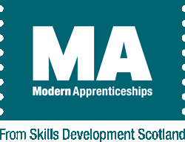

**Modern Apprenticeship in Dental Nursing**

As a registered Training Provider with Skills Development Scotland (SDS), NHS Education for Scotland (NES) now provides Modern Apprenticeships (MAs) and will fulfil the requirements of the SDS Quality Assurance and Improvement Framework.

**What is a Modern Apprenticeship?**

Modern Apprenticeships offer those aged over 16 in paid employment the opportunity to train and work towards a vocational qualification.

**How does the Modern Apprenticeship in Dental Nursing change the way NES currently provide dental nurse training?**

In short, there is little difference for employers or Apprentices. The student dental nurse will still undertake The Scottish Qualifications Authority (SQA) **Scottish Vocational Qualification (SVQ) & Professional Development Award (PDA) in Dental Nursing.** Upon successful completion, the student will be able to register with the General Dental Council (GDC).

In addition, students will evidence the five **SQA Core Skills Units** in Communication; Working with Others; Problem Solving; Information and Communication Technology; and Numeracy as they progress through the Modern Apprenticeship programme.

**What does it mean for Students?**

* Attend our pre-registration training programme and work towards achieving their registerable qualification. As a Modern Apprentice you work towards your qualification whilst in employment.
* Support from the NES DCP Team and your workplace throughout the duration of your training.

**What does it mean for Employers?**

* Employ and support the ongoing progress and development of students throughout the duration of their training.
* Assist students in completing the relevant registration documentation for SDS and SQA. This documentation will be issued by NES and is very similar to that used with previous students.
* Employers will receive regular feedback and will be required to review and sign progress documentation throughout the course.
* In the same way that SQA reserves the right to visit a student in their workplace, on occasion Skills Development Scotland may contact employers for feedback regarding their progression.
* Places are now free of charge, saving £750.00. Modern Apprentices will also save the SQA registration fee.

**Programme Entry Requirements:**

* Three qualifications at SCQF level 4 (e.g. Standard Grades at ‘General’ or above, or National 4 or above) in English; Maths; and a Science subject.
* Successful completion of the NES Dental Nurse Induction Programme within the preceding two years.
* Employed in a dental practice environment in Scotland, working clinically alongside a dentist or hygiene therapist covering a full range of clinical dental procedures for a minimum of 15 hours per week

**Further information on the Modern Apprenticeship in Dental Nursing can be found here:**

[**https://www.apprenticeships.scot/for-employers/browse-frameworks/modern-apprenticeships/dental-nursing/**](https://www.apprenticeships.scot/for-employers/browse-frameworks/modern-apprenticeships/dental-nursing/) **or contact:** [**dcp.hub@nes.scot.nhs.uk**](mailto:dcp.hub@nes.scot.nhs.uk)

**Peer Review and Quality Improvement**

**15 =?**

**15 = the number of hours of approved audit activities you will need to undertake August 2019 – July 2022 if you hold a list number.**

**15 = 7.5 + 7.5**

**7.5 = the maximum hours available for leading a Peer Review Project**

**15 = 7.5 + 6 + 1.5**

**6 hours = the maximum hours available for participating in a Peer Review Project**

**1.5 hours could be awarded for writing up a ‘Significant Event’**

**Think about planning a Peer Review Project for Winter 2019/20 with colleagues in your practice/group of practices/ on call rota.**

**NB** Peer Review does **not** mean someone is ‘*looking over your shoulder’*

**Find out what Peer Review is:**

[**https://www.nes.scot.nhs.uk/education-and-training/by-discipline/dentistry/areas-of-education/professional-development/quality-improvement-activity/peer-review.aspx**](https://www.nes.scot.nhs.uk/education-and-training/by-discipline/dentistry/areas-of-education/professional-development/quality-improvement-activity/peer-review.aspx)

Portal is currently closed for applications however help with planning is available: [**nhsg.dentalaudit@nhs.net**](mailto:nhsg.dentalaudit@nhs.net)

**MCN Annual Report 2018/19**

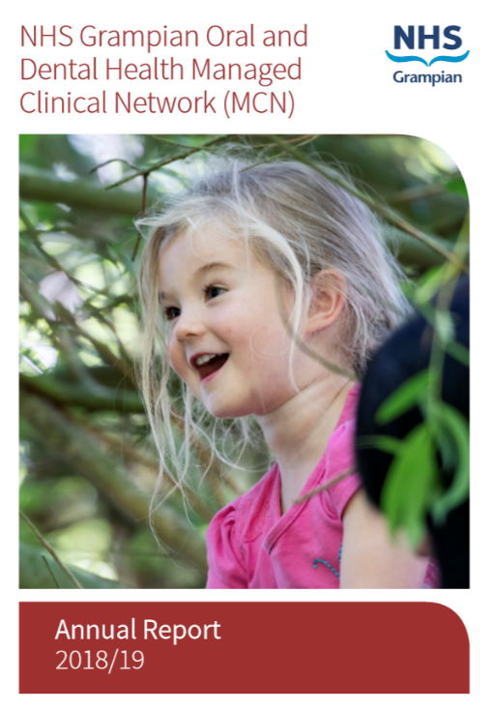

The Grampian MCN for Oral & Dental Health team have published their 2018/19 annual report: [**www.hi-netgrampian.org/wp-content/uploads/2019/06/ODH-MCN-Annual-Report-2018-19-FINAL-1.pdf**](http://www.hi-netgrampian.org/wp-content/uploads/2019/06/ODH-MCN-Annual-Report-2018-19-FINAL-1.pdf)

This is a snapshot of some of the achievements of last year, as well as areas for focus in 2019/20, to provide a few of the highlights. As dental teams, you are the frontline for oral health care and as such we value your input. We also thank you all for the great work you are doing, as these activities do not take place in isolation and improvements in oral health only arise from a concerted effort by all of us.

The MCN consists of dental and oral care professionals working together across Grampian to improve patient experience and outcomes. It is an inclusive network so feel free to contact with any opinions, views or thoughts on areas that you feel may need attention regarding oral care in Grampian - our email address is [**nhsg.mcn-odh@nhs.net**](mailto:nhsg.mcn-odh@nhs.net)

As always, more information on the work of the MCN can be found in these newsletters and also at our website: [**www.hi-netgrampian.org/dentalmcn**](http://www.hi-netgrampian.org/dentalmcn)