**Grampian Oral & Dental Health Managed Clinical Network (MCN) Newsletter**

ISSUE 2 – April 2019

|  |  |
| --- | --- |
| **Contents**  Intro to Dental Practice Advisor - 1  Oral Health Improvement Plan Update - 2  Local Dental Committee – 2  Dental Quality Improvement – GDP recruitment– 3  Your local QI Panel – 4  The Role of Oral Health Team Leaders - 5 | Review of Dental Referral Pathways – 7  Tobacco Free Generation Award – 7  Caring for Smiles Database – 7  Childsmile claim codes, GDPs – 8  Shared Care - 9 |

**Introduction to NHS Grampian’s new Dental Practice Advisor (DPA)**

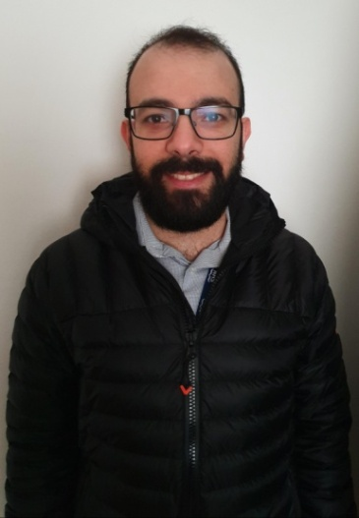I am honoured to have been appointed the new dental practice adviser for NHS Grampian.

Having qualified at Dundee Dental School I have worked in general practice at Grandholm Dental Clinic in Aberdeen since doing so.

As a generalist, I understand the day to day reality of providing care to our patients. The job of a GDP is taxing and the march of clinically related administration appears to be relentless, adding to our already large workloads.

I am available to offer what advice I can, and hope to be a supportive, friendly and approachable dental practice adviser. I hope that through this role I will be able to work with all my colleagues including principals, associates, VDPs and assistants to support each other to improve the quality of care we provide our patients in Grampian.  
​

Amro Alkado

Dental Practice Adviser

grampian.dentalcontracts@nhs.net​

**Let us hear from you!**

We would like the newsletter to be informative and contain articles you are interested in. We would love to hear any feedback regarding this issue. Please send any comments, ideas or articles to [**nhsg.mcn-odh@nhs.net**](mailto:nhsg.mcn-odh@nhs.net)**.**

Deadline date for submissions: Friday 19th July 2019.

**Oral Health Improvement Plan (OHIP) Update**

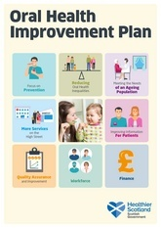An update document from the Scottish Government was disseminated to all practices in February 2019 – this outlined the communication channels they will use to keep practitioners abreast of developments and the phased order of recommendations to be implemented.

An opportunity to participate in the early adopter programme for domiciliary care arrangements was recently provided, with interest noted from a number of dentists across Grampian. National selection criteria was applied to applications with 40 places for training available across Scotland. Once the training has been completed, a mentoring programme from Public Dental Service (PDS) colleagues will be initiated. More information on this will be shared in due course.

Jonathan Iloya  
Interim Director of Dentistry  
NHS Grampian

**Local Dental Committee**

NHS dentistry in Grampian has gone from strength to strength in the last decade with many new practices being set up and patients in the region having a choice of NHS dentists for the first time. With that in mind, I think it is of utmost importance that General Dental Practitioner voices are heard given the fact we care for the vast majority of registered dental patients in Grampian.

I am deeply passionate about GDPs getting a fair deal and with the Scottish Government’s OHIP for Scotland currently in the works, there is no better time for us in Grampian to join the debate on what is likely to be the biggest shift in dentistry in Scotland in a generation. This means having input from GDPs through the local dental committee (LDC), which currently and disappointingly does not exist in Grampian.

The LDC is concerned with a broad range of important issues affecting GDPs and also acts to represent and support local practitioners. It plays a significant role locally by advising the Grampian Health Board on relevant matters, and nationally, with representatives of each LDC meeting at national conferences annually.

We are looking for GDPs, regardless of experience, throughout Grampian who are interested in joining the committee to get in touch expressing their interest, please send an email in to: grampianldc@outlook.com

Your input will be greatly welcomed and will be a very important step for the profession in Grampian.

Amro Alkado

Dental Practice Adviser

**Dental Quality Improvement – GDP recruitment**

***For all General Dental Practitioners in NHS Grampian***

***Are you interested in making a difference to Dental Quality Improvement in your local area?***

Your local NHSG Dental Quality Improvement (QI) panel is pleased to announce that we are now in a position to recruit an enthusiastic GDP member to represent the interests of independent general practice.

**This panel has several functions:**

* To support all GDS and PDS practitioners in NHSG in undertaking and completing useful Dental Clinical Quality Improvement Activity.
* To provide a local source of QI information.
* To help with understanding of the QI rules and regulations as determined in the NHS Dental Terms of Service.
* To provide accreditation for projects meeting the necessary prerequisite criteria
* To provide local high-quality joint projects for all GDS/PDS to join.
* To support those who do not complete QI activity as required in the regulations.
* To provide NHSG with details of hours of QI completed by dentists

The panel at present comprises a panel lead, PDS clinical lead and our NHSG Dental Practice Adviser. We have some input from the University of Aberdeen Institute of Dentistry and Dental Hospital also. We would very much like a GDP member to join us to ensure that what we discuss, and plan works in and represents general practice.

**What does this role entail?**

* Attendance at panel meetings. These happen 4-5 times per year usually on a Thursday morning.
* Participation in email discussions when pertinent issues arise.
* You need to be enthusiastic about QI, patient care and raising standards of clinical care.
* You should be keen to support peers and treat all personal/practice information as confidential.
* A willingness to share knowledge and experience to help others is essential.
* Initial commitment of 1 year participation.

**Remuneration**

To make an application for this position please email [nhsg.dentalaudit@nhs.net](mailto:nhsg.dentalaudit@nhs.net) with a statement that describes your interest in this role and any experience you have in this area. **Closing date for applications is 26th April 2019.** For any informal queries please contact the panel lead Claire Paton at [claire.paton@nhs.net](mailto:claire.paton@nhs.net)

**Dental Quality Improvement (QI) in Grampian – Your local QI Panel**

This article contains reminders about important deadlines and some QI FAQs.

Please note carefully the following:

**The current Dental Quality Improvement (QI) cycle ends on 31st July 2019. All NHS dental practitioners who have a list number are contractually obliged to complete 15 hours of QI activity in every 3-year cycle.  If you have not achieved this or put in place plans to complete your required hours for this cycle you need to act now.**

**Reminder to all practitioners: Non-compliance with QI requirements may result in action against individuals and practices being taken by the Health Board.**

**Please remember that maternity leave does not change the number of QI hours you are required to complete**

Your local panel is here to help you so please email [nhsg.dentalaudit@nhs.net](mailto:nhsg.dentalaudit@nhs.net) and we will do our best to assist you.

**QI/AUDIT Frequently Asked Questions**

1. What activities ‘count’ in my hours for Quality Improvement Activity?
   * **Dental Audit** – either joining a large project or designing your own
   * **Enhanced Significant Event Analysis (SEA)**
   * **Peer Review**
   * **Dental Practice Based Research**

NES Website for links to details of these: <https://www.nes.scot.nhs.uk/education-and-training/by-discipline/dentistry/areas-of-education/professional-development/quality-improvement-activity.aspx>

1. What can I do now if I need hours before 31/7/19?
   * The NES Portal is CLOSED to all AUDIT and PEER REVIEW applications (national projects and bespoke projects)
   * **The NES Portal is OPEN for enhanced SEA projects**
   * New Research projects will become available after 1/8/19

* **NHSG are still offering 2 audit projects but you would need to start them immediately to allow a chance to complete a meaningful project before 31/7/19**. To find out more please email [nhsg.dentalaudit@nhs.net](mailto:nhsg.dentalaudit@nhs.net). The projects are:

1. A Dental Clinical Audit of pre/post treatment communication with patients and obtaining valid consent for dental treatment. 7.5 hours
2. NHSG Periodontal Record Keeping Audit. 7.5 hours
3. How do I get help with current projects?

* If the project was approved by NES (some audits, all Peer
* Review and all SEA’s) you need to seek advice from the Portal. Each project on your dashboard page will usually have a ‘contact admin’ button which you can use to send a message

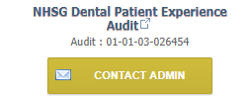

* If the project was approved by NHSG the panel email address above can be used to contact us. We are also happy to help with any general queries about QI.

1. Where do my QI hours get logged?
   * Any NES project will be listed on your NES Portal account
   * Current NHSG Projects do NOT appear on your Portal account but DO count towards your QI hours total and are held securely by NHSG
   * At the end of the QI cycle it is the health board’s responsibility to check if each person with a dental list number has completed the requisite hours of QI activity and data from NHSG and NES will be consulted.

**Plans for the new QI cycle starting 1/8/19**

This QI cycle will run from 1/8/19 to 31/7/22

NHSG plans to offer high quality projects for GDS and PDS use and to continue to work alongside NES to support practitioners and improve patient care. A third round of the popular Consent and Communication project will run for those eligible and PDS projects around dental sedation and record keeping are planned also.

Claire Paton

NHSG Dental Quality Improvement Lead & PDS Dental Officer

**The Role of Oral Health Team Leaders in Grampian**

Improving oral health for priority groups including older people in care homes, the homeless, those with additional care needs and those in prison, was identified as a key priority in ‘An Action Plan for improving oral health and modernising NHS Dental Services’ (Scottish Executive, March 2005), and the subsequent ‘National oral health improvement strategy for priority groups: frail older people, people with special care needs and those who are homeless’ (Scottish Government, May 2012).

Here in Grampian, our oral health team leaders are actively promoting and delivering training

and raising awareness with those that provide oral care and support to people within these groups to ensure that their oral health care is looked after effectively and that their oral health improves.

There are several national and local programmes of training that are currently provided by the team leaders including:

1. **Caring for Smiles** - Scotland's national oral health promotion training and support programme, which aims to improve the oral health of older people, particularly those living in care homes, through the education of care staff.
2. **Smile for Life** – training to staff working directly with people experiencing homelessness.  The overall purpose of Smile4life is to enable health and social care staff and support workers to provide evidence-based tailored oral health messages to meet the specific and exceptional needs of homeless (roofless and houseless) people in Scotland.
3. **Mouth Matters** – training to enable health professionals, prison staff and support workers to meet the specific oral health needs of offender populations in Scotland. To raise awareness of the key oral health risk factors and provide skills that can be used to support an oral health brief intervention tailored to offenders.
4. **Open Wide** – training for staff working directly with people who have additional care needs, to ensure that oral health is supported.
5. **Oral Health training, support and advice:**

* for those working with drugs and alcohol misuse/dependant
* mental health
* travellers
* those providing home care to sick, frail and elderly

If you would like any further information or would like to hear more about what support is available please see contact details below:

**Aberdeen City**

Oral Health Promotion Team Leaders

Aberdeen Health Village

Tel: 01224 655674/655675

Email: [nhsg.cityohpteamleaders@nhs.net](mailto:nhsg.cityohpteamleaders@nhs.net)

**Aberdeenshire**

Diane Lawson

Oral Health Team Leader

Tel: 07557 317805

Email: diane.lawson1@nhs.net

**Moray**

Oral Health Team Leader

Spynie Dental Centre

 Tel: (01343) 559878

Email: nhsg.ohimoray@nhs.net

**Review of Dental Referral Pathways**

As highlighted in the last newsletter, local dental referral pathways are being reviewed.

We would like you to have your say and invite you to complete a survey via the following link:

<https://www.snapsurveys.com/wh/s.asp?k=155385136256>

The survey will remain open until 20th April. Thank you for your help in shaping this update.

​

Hilary Bell,

Senior Public Health Practitioner

**Tobacco-free Generation Award from ASH Scotland**

NHS Grampian has been nominated to receive a Tobacco-free Generation Award from ASH Scotland in recognition of the important contributions we are making towards creating a tobacco-free generation. ASH Scotland were particularly encouraged to hear about the way NHS Grampian has chosen to make use of the Charter as a way to improve engagement between the Stop Smoking Services and both Pharmacy and Dentistry. All the dental practices that have signed up have contributed to this achievement.

If you would still wish to sign up, please contact Carole-Ann Duff at [caroleannduff@nhs.net](mailto:caroleannduff@nhs.net).

Over 300 organisations across Scotland have now pledged their support to the Charter and are taking practical steps to help work towards a tobacco-free generation of Scots by 2034. These awards have been developed as part of Scotland’s Charter for a Tobacco-free Generation to recognise the significant contributions of organisations like ours.

**Caring for Smiles database**

Claire Hutcheon, Public Health Administrator, has recently completed the NHS Grampian Careers Aspirations Programme. As her chosen project, she showcased her work on the Caring for Smiles database. This enables a more accurate collation of training data used for reporting to NHS Grampian Board and the Scottish Government.

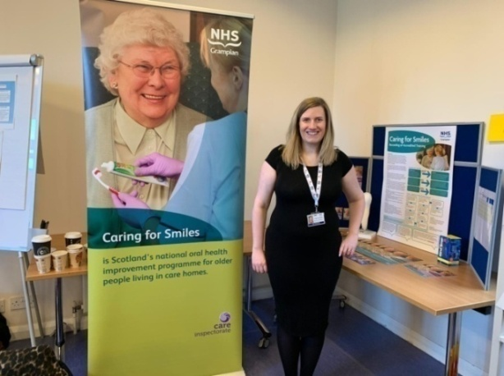

**CHILDSMILE: You asked – we listened**

**We received feedback from some GDPs who were unsure which codes to claim for Childsmile, so we hope this helps make it a little clearer.**

**0-2 YEAR OLD**

**ONLY**

**3-5 YEAR OLD**

**ONLY**

**TOOTHBRUSH**

**INSTRUCTION**

**4103 - Dentist**

**4104 - DCP**

**TOOTHBRUSH**

**INSTRUCTION**

**4107 – Dentist**

**4108 - DCP**

**DIETRY**

**ADVICE**

**4105 – Dentist**

**4106 - DCP**

**DIETRY**

**ADVICE**

**4109 – Dentist**

**4110 - DCP**

**IMPORTANT**

**Include SIMD fee**

**4111 – SIMD 1-3 (£5.62)**

**NO FEE code for SIMD 4-5**

**IMPORTANT**

**Include SIMD fee**

**4101 – SIMD 1-3 (£17.14)**

**4102 – SIMD 4-5 (£5.62)**

**To be claimed ONCE a year, but carried more if required and documented in patient notes**

***APPLICATION OF FLUORIDE VARNISH TO ALL CHILDREN 2 – 5 years inclusive TWICE PER YEAR IRRESPECTIVE OF NEED***

**4407 *- £6.70***

* **PLEASE ENSURE THAT CHILDREN ARE REGISTERED FROM 6 MONTHS OF AGE, this ensures that parents receive information tailored to the age of their child with regards to diet and techniques to toothbrush.** Information given to parents is vital at the earliest possible age.
* For children from age 6 to 17 inclusive it is worth noting that although there are no codes to claim, the above toothbrushing, diet and fluoride applications are still to be carried out.
* For those children who have a postcode in **SIMD 1** a further 21p is added to the monthly capitation payment. You can refer to the SDR pages 40-44 which will show all the above in more detail.

<https://www.scottishdental.org/wp-content/uploads/2019/01/Amendment-No-140.pdf>

* If you are experiencing difficulties in receiving payments make sure that the correct postcode has been used, if this is incorrect it will automatically default to a no payment or that of the lower payment. There also needs to be a clear 12 months between claims.
* Your Childsmile Co-ordinator will be happy to come out and discuss this in detail if required and is always on hand for help and advice.

**DONT FORGET TO KEEP TOPPED UP WITH OUR CHILDSMILE RESOURCES FREE TO ALL PRACTICES**

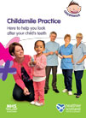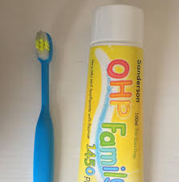

**Shared Care**

Shared care is an important concept in the oral care of patients, especially those who may have additional needs or difficulty in accessing all their care from a high street dentist.

It is a concept which is considered in Scotland’s new Oral Health Improvement Plan.

It involves all health professionals and other people involved with the care of a patient to ensure that they are cared for and treated according to their needs.

It is not always straightforward to coordinate and so we have prepared a short information sheet on shared care, please see the link here:

<https://www.hi-netgrampian.org/people-networks/managed-clinical-networks/nhs-grampian-mcn-for-oral-and-dental-health/special-care-dentistry/>

We would also very much like any feedback to [nhsg.mcn-odh@nhs.net](mailto:nhsg.mcn-odh@nhs.net) on what may or may not be useful to include in such an information sheet in the future.

Iain Bovaird

Clinical Lead, Managed Clinical Network (MCN) for Oral & Dental Health