**Grampian Oral & Dental Health Managed Clinical Network (MCN) Newsletter**

ISSUE 1 – DECEMBER 2018

|  |  |
| --- | --- |
| **Contents**  Report from MCN Clinical Lead - 1  Education, Training & Development Group Update - 2  A Peer Review Group Experience – 3  Dental Contracts – 3  Dental Referral Pathway – 3  Let’s Talk About Mouth Cancer - 4 | Dental Practice signs tobacco free charter – 5  Resources for RACH – 6  National Dental Inspection Programme – 6  Scotland’s Oral Health Improvement Plan – 7  Contact Us/Feedback - 7  Dental Quality Improvement - 7  Childsmile - 8 |

**MCN Clinical Lead Report**

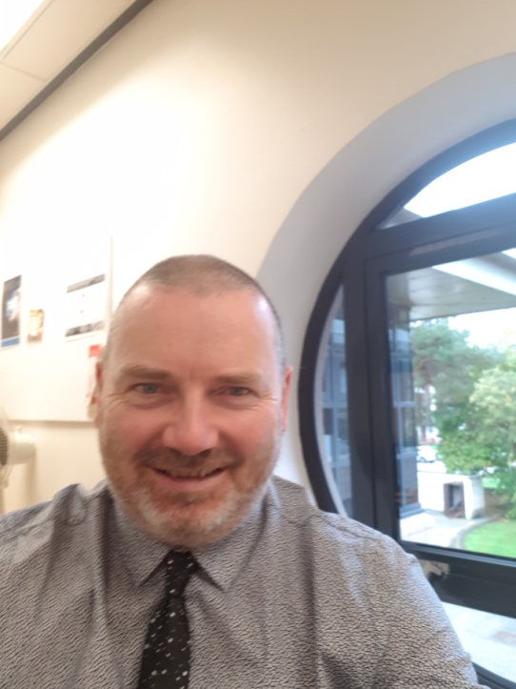Having been in post for a year, I felt it would be a good time to reflect on the MCN for oral and dental health. I am indebted to Jenna Bews, our MCN manager, and Jonathan Iloya, our interim Director of Dentistry, for their continued support and advice.

I have had an interesting time over the last year, engaging as much as possible with the sub groups and those from other local networks, including diabetes and eye health.

This has reminded me how useful it is to look outside the profession to address common issues, such as compliance with health messages.

Within the profession, I am keen to maintain and strengthen engagement with the Public Dental Service and engage with our GDP and secondary care colleagues more effectively. We are actively trying to seek innovative ways of doing so.

We have six subgroups within the MCN grouping;

* Special Care chaired by Lois Gall,
* Oral Health Improvement chaired by Karen Tosh,
* Surgical Dentistry chaired by Bernice McLaughlin,
* Children’s Dentistry chaired by Malcolm Stewart,
* Education, Training & Development chaired by Christine Horner
* Sedation & Anxiety Management chaired by Mike Brown.

Our annual report shows how we have progressed this year and, over the next 12 months, we are looking to develop the role of the MCN in order to achieve better oral care provision for our population, by engaging with all stakeholders and providing support to projects and developments which improve oral health. For further information please follow the link [NHS Grampian Managed Clinical Network (MCN) for Oral and Dental Health | Hi-Net Grampian](https://www.hi-netgrampian.org/people-networks/managed-clinical-networks/nhs-grampian-mcn-for-oral-and-dental-health/)

Iain Bovaird

MCN Clinical Lead

iain.bovaird@nhs.net

**Education, Training & Development Group Update**

A ‘Training Needs Analysis’ (TNA) was completed by the MCN's Education, Training & Development Group (ETDG) in early 2018.  A brief report of the findings from the TNA is available [here](https://www.hi-netgrampian.org/people-networks/managed-clinical-networks/nhs-grampian-mcn-for-oral-and-dental-health/education-training-development/) on Hi-Net. This was followed by the identification of gaps in the local provision of CPD by NHS Education Scotland (NES).  The TNA evidence was used to gain NES Management approval for dissemination of an eLearning package on ‘Oral Cancer Awareness’ to all NHSG List number holders and teams prior to Mouth Cancer Awareness Month 2018.  The TNA evidence has also resulted in a NES ‘Hands-on/Blended Learning’ Endodontics course coming to Aberdeen in November 2018.

The ETDG are continuing to share our findings with MCN subgroups and other disciplines - this is strengthening our relationships with colleagues, improving networks and helping to plan future workforce training.

Christine E M Horner

christine.horner2@nhs.net

**A PEER REVIEW GROUP EXPERIENCE**

**By Rebecca Binnie, The Dental Practice, Aberdeen**

A few years ago I had the privilege of organising and being part of a Peer Review group. Eight (mainly) GDPs from four practices met three times over three months to review and develop our Practice Policies on Child Protection.

The first session involved sourcing the appropriate current guidelines and documents. Our existing policies and procedures were then appraised against them. We invited a consultant paediatric dentist to our second meeting to clarify key areas identified at the initial meeting. He also addressed implications of the current guidelines with respect to general dental practice. Following this, each member reviewed their own practice policies, implementing changes and team training where appropriate. The final meeting discussed the new policies created from the updated and collated material and addressed any outstanding issues.

My experience of the Peer Review Process was a positive one. The process helped focus preparation, provided structure for the meetings and utilized time effectively. The sharing of ideas and critical appraisal with colleagues in a supportive and constructive environment is one which I found very beneficial and am keen to repeat.

**Let us hear from you!**

We would like the newsletter to be informative and contain articles you are interested in. We would love to hear any feedback regarding the very first issue of our newsletter. Please send any comments or ideas to **nhsg.mcn-odh@nhs.net**

Deadline date for submissions: Friday 8th March 2019. Please send any articles to **nhsg.mcn-odh@nhs.net**

**Dental Contracts**

This year has seen changes in the Dental Contracts Team. Reece Davidson has decided to tour Australia for a year and left the department on 17th October. He was given a warm “going away” from his many colleagues who were all rather envious. Craig Marr has now taken on some Dental work alongside Barbara Donald. The Team would like to remind all dentists and practices that communication with the Dental Team should be via the generic e-mail account only, [grampian.dentalcontracts@nhs.net](mailto:grampian.dentalcontracts@nhs.net) and from personal and practice nhs e-mail accounts only.

The Team would also urge all dentists and practices to regularly check their nhs e-mail

accounts for information that may affect them or require their attention.

David Shaw

Dental Practice Adviser

Grampian.dentalcontracts@nhs.net

We are delighted to inform you of a recent 2018 Scottish Health Award recipient. Ann Ovall a Public Service dentist at NHS Grampian’s Health Care Village picked up the award at the event at the Corn Exchange in Edinburgh in November. For details please see the link [here](http://nhsgintranet.grampian.scot.nhs.uk/depts/UpFront/UpFront%20Documents/UpFront%202018/UpFront%20-%20December%202018.pdf).

**Dental Referral Pathway**

It has been several years since the Grampian dental referral guidance document was fully up-dated and following on from the rollout of the SCI Gateway system it is a good opportunity to review all the pathways and redesign the guidance, information, forms and documentation. I shall be working on this project alongside you, the dentists and the clinical leads to progress it and ensure a smooth, user-friendly outcome.



As part of this review, we need your views and participation to make it happen.

**We’re listening!**

We are keen to listen to you and will shortly be producing and issuing a survey/ holding focus groups to find out how the system could be improved **whether or not** you have used the new SCI gateway system. If you would like to represent the GDS on this piece of work please get in touch via [nhsg.mcn-odh@nhs.net](mailto:nhsg.mcn-odh@nhs.net)

**Who am I?**

I have been working in Public Health for almost 10 years and have previously been involved in HEAT 3 target projects (Child Healthy Weight) and am

currently a Senior Public Health Practitioner in the Public Health Directorate, NHS Grampian My prime focus is workplace health improvement. This short life project is in addition to my current duties.

**Let’s Talk About Mouth Cancer**

Hilary Bell

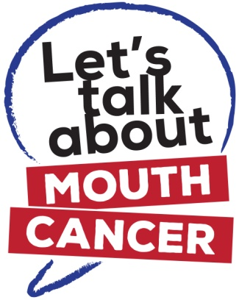



**NHS Grampian launches a new Mouth Cancer Campaign**

NHS Grampian’s Public Health Directorate has launched a new campaign aimed at raising awareness of Mouth Cancer and the importance of checking your mouth regularly. The campaign will promote the Let’s Talk about Mouth Cancer website and resources as well as promote a 2 minute video showing how to check your own mouth.

The campaign launched in November during Mouth Cancer Action Month with a social media campaign and also resources sent to health professionals and those working with groups who may be at increased risk. The campaign will be promoted throughout the next 12 months in a series of social media adverts, local events and also training for relevant staff and partners.

The launch took place at the Bon Accord Centre where dental students spoke to the public and showed them how to check their own mouths. The charity patron Scott Hastings (ex-international rugby player) also provided a video to help launch the campaign.

In Scotland, 4,721 people were diagnosed with mouth cancer1 in 2016 – that’s 13 people every day. There were 358 deaths related to mouth cancer in 2016, up by 15% from the previous year. It is one of the few cancers on the rise – especially in younger adults - and it still claims more lives than cervical and testicular cancer combined.

Sadly, survival rate at 5 years is only 56%, as the majority of cases are only detected at a late stage. With early detection and diagnosis, survival rate increases to more than 90%.

**How the dental team can help**

Please help support the Let’s Talk about Mouth Cancer campaign by:

1. Displaying the posters and leaflets in your waiting room / reception area (November is Mouth Cancer Action Month).
2. Playing the Mouth Cancer Check video on waiting room screens (found at [www.LTAMC.org](http://www.LTAMC.org)) <https://www.youtube.com/watch?v=qjJichWvTFk>
3. Engaging patients in conversation about the risk factors associated with mouth cancer (i.e. reducing smoking and drinking)
4. Providing patients with supportive information, for example, leaflets covering the topics of smoking cessation and sensible drinking (available through the Resources Service below)
5. Encouraging patients to contact their dentist or doctor should they have any concerns
6. Watch out for future events including social media adverts, CPD, training etc.

**Please note, additional leaflets and posters can be ordered free of charge from NHS Grampian’s Health Information Resources Service by telephoning 01224 558504 or online by visiting**

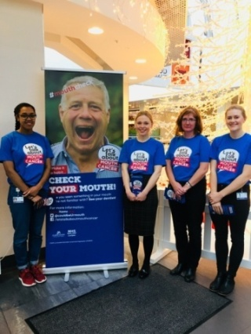[**http://www.nhsghpcat.org/HPAC/Index.jsp**](http://www.nhsghpcat.org/HPAC/Index.jsp)**.** If you require any further information about the campaign, please visit [www.LTAMC.org](http://www.LTAMC.org) or contact Karen Tosh by email at [k.tosh@nhs.net](mailto:k.tosh@nhs.net) or telephone 01224 558524.

**1Mouth Cancer includes cancer of the lip, oral cavity and pharynx.**

**First Dental Practice in Grampian signs up to support**

**Scotland’s Charter for a Tobacco-free Generation**

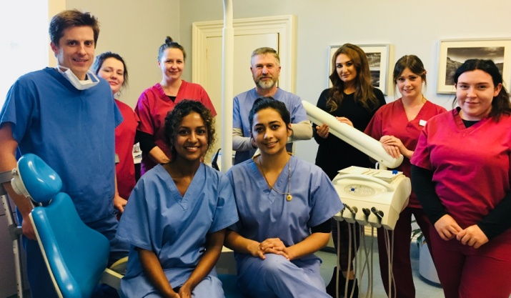**King Street Dental Practice** in Aberdeen are the first dental practice in Grampian to sign up to support Scotland’s Charter for a Tobacco-free Generation. They will also participate in a pilot exercise for a new advice card to signpost patients to stop smoking support.

**Scotland has a vision of creating a tobacco-free generation with fewer than 5% of the population still smoking by 2034.**

NHS Grampian, with support from ASH Scotland, is approaching dental practices in Grampian to show support for this ambitious target by endorsing Scotland’s Charter for a Tobacco-free Generation. There are now over 16 practices signed up with others joining every day. Signing up provides recognition to the practice for work underway and to inspire further action to reduce the harm caused by tobacco.

ASH Scotland, the British Dental Association, the Oral Health Foundation and NHS Inform Scotland have worked together to produce the card which is tailored to dentistry and is designed for the dental team to give out after asking the question “have you thought about quitting smoking?”

If your dental practice would like to register as a Charter supporter you need only pledge to make use of the advice cards over the next 3 months. If you wish to, you can make several other pledges that would help to support the aims of the Charter.

For more information please contact Carole-Ann Duff at [caroleannduff@nhs.net](mailto:caroleannduff@nhs.net).

**Oral Health Resources for RACH**

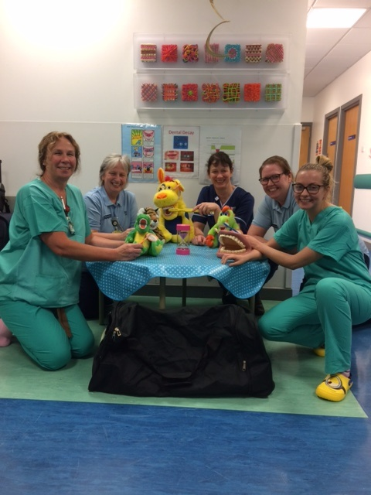

A bag of oral health promotion resources has been delivered to the Day Case Unit at RACH. These resources will be used by staff with dental patients attending for multiple tooth extractions and require a general anaesthetic. It is hoped that the resources will promote good tooth brushing skills at home. Receiving the resources are Tracy Dickson, Dental Nurse, Ann Buchan, Play leader, Sue Denby, Senior Charge Nurse, Wendy Joss, Play Specialist and Anna Chrystal, Dentist.

**National Dental Inspection Programme (NDIP)**

The 2018 National Dental Inspection Programme (NDIP) report, published in October, shows that the oral health of Primary 1 children in Grampian is much better than observed in the last inspection in 2016.

There has been a considerable improvement in the proportion of children with no obvious decay experience, from 70% to 76%, and the number of teeth affected by decay experience (dmft) has also dropped from 1.09 to 0.89. These improvements are reflected across the Aberdeen City, Aberdeenshire and Moray Health and Social Care Partnership areas as well.

These local improvements are testament to the hard work and dedication of dental and oral health teams across Grampian.  However, oral health inequalities still persist and reducing these inequalities remains one of the key priorities for NHS Grampian’s Childsmile programme.

**Scotland’s Oral Health Improvement Plan**

This was published earlier in the year with 43 recommendations to take forward. The Scottish Government identified five as their initial priorities to progress:

1. Director of Dentistry appointed for each NHS Board;
2. Occupational health service for GDPs, members of the dental team and other practice staff;
3. Publish a pathway to support dental practitioners locally;
4. Introduce arrangements to enable accredited GDPs to provide domiciliary care for care homes residents;
5. Introduce a new three-year Community Challenge Fund for Oral Health Improvement.

These priorities are being progressed and some have been completed. We will communicate with local practitioners to advise of further developments when information is made available. Meantime, if you wish to provide any feedback on the recommendations detailed within the plan and the impact these may have locally, please feel free to email our MCN address: [nhsg.mcn-odh@nhs.net](mailto:nhsg.mcn-odh@nhs.net).

**Dental Quality Improvement (QI) in Grampian**

The NHSG Dental Quality Improvement panel is very active in encouraging clinicians to not only meet their statutory QI requirements but in trying to foster an attitude of inquiry into how we can help to make dental care safe and effective for our patients.

In excess of 50 practitioners (PDS and GDS) took part in and completed the recent NHSG project on ‘Consent and Communication’. This was a great response and demonstrates a desire for local projects to be readily available. As part of this project, a small group of PDS practitioners worked together to develop 13 patient information sheets that are now available across the PDS in NHSG

In addition to this project, within the current QI cycle, NHSG have offered a project on Periodontal Record Keeping for everyone and for a PDS only focus there has been work done in the recording of accurate Case mix scoring and domiciliary care. A project on sedation assessment has just been released in Aberdeen City and Aberdeenshire PDS and a general record keeping audit is planned for Moray in 2019.

We handle lots of enquiries from both GDS and PDS practitioners about individual projects / requirements and also liaise with Primary Care Contracts to establish who has met their statutory requirement for QI activity.

Peer Review has been used widely and successfully within the PDS but uptake in GDS is still very low.

Longer term plans may focus on projects that run over a longer time span to really examine what is happening in a certain clinical instance or system to see if change is needed, and very importantly, that changes made really do result in improvement that is sustained.

***Clinicians – please note that the current QI cycle finishes on 31/7/19 and most of you will need to have 15 hours of verified QI activity completed by then.***

We are very happy to answer any QI queries so please e-mail us at [nhsg.dentalaudit@nhs.net](mailto:nhsg.dentalaudit@nhs.net) and we will do our best to assist you!

Claire Paton

**Childsmile celebrates 10th year of service**

**in Aberdeenshire!**

This Government Funded oral health programme has developed to include tooth brushing in virtually every nursery across Aberdeenshire, and selected schools.

The Childsmile teams are located in four areas across Aberdeenshire, Peterhead, Fraserburgh, Huntly and Laurencekirk. The teams consist of Dental Health Support Workers and Dental Nurses, who travel the length and breadth of Aberdeenshire, to share their Oral Health Messages and deliver resources and oral health talks. Look out for the Childsmile Van coming your way!

****According to the 2018 National Dental Inspection Programme (NDIP) report, 74% of children at Primary One stage presented with no obvious dental cavities in Aberdeenshire, which is great news. However we feel we can do even better if we can support even more children to improve their oral health in deprived areas, where there is less access to oral healthcare services.

Annette Johnson

Childsmile Co-ordinator

Email: [annette.johnson2@nhs.net](mailto:annette.johnson2@nhs.net)

Telephone: 01569 792054

07500 033767

**For any further information, please contact:**

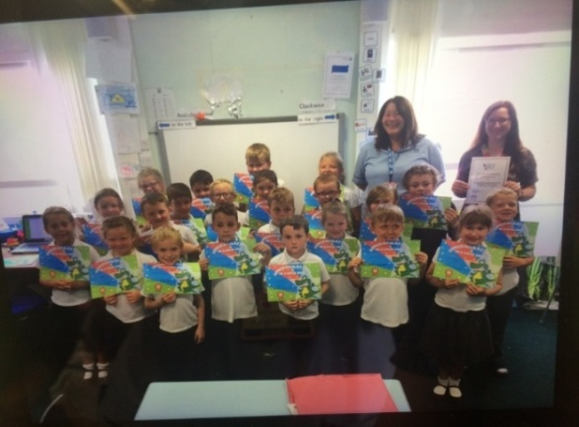

Rona Geddes, Dental health Support Worker Childsmile presents Lochpots Primary 2/3 class and teacher with their certificate for Highest Standard toothbrushing in Fraserburgh

Lynne Taylor, Dental Health Support Worker for Childsmile presents Balmedie School Nursery and staff with their Childsmile Certificate for 2018, for achieving the highest standard of Daily Supervised Toothbrushing.