Referral Form for Oral & Maxillofacial Surgery

Send to: Maxillofacial Unit, Aberdeen Royal Infirmary, Foresterhill Aberdeen, AB25 2ZN

Need to speak to an on-call clinician? The Maxillofacial Department is on call 24/7.
In an emergency, telephone advice is always available on; 0845 4566000 (ARI hospital switchboard) and ask for SHO/FY2 on call – bleep 2340. The consultant on call can also be contacted via the SHO on call or via the departmental secretaries.

The fastest method of referral is via the electronic SCI Gateway: click on Head and Neck Cancer
If you do not have access to this, fax a copy of this form to: 01224 554865 DO NOT SEND FORMS BY EMAIL.

A. Patient’s Personal Details |  |  |  |  |  | Please insert dates in dd/mm/yyyy format
Date of Referral |  |  |  |  |  | Surname
Gender | Male |  | Female |  |  | Forename
CHI Number |  |  |  |  |  | Date of Birth
Address
Town |  |  |  |  |  | Postcode
Daytime Phone |  |  |  |  |  | Mobile
Home Phone |  |  |  |  |  | e-mail

If your patient needs to communicate in a language or mode other than English please specify:
If yes, please specify and state whether an accompanying person can translate or if an interpreter will be needed.

URGENT: |  | YES |  |  |  | NO
If URGENT, please mark one or more of the following:
Malignancy suspected |  | Pain for 48 hours |  | Swelling |  | Trauma
Other (please specify)

To aid compliance with the Disability Discrimination Act, please indicate if patient has any special mobility requirements :
Mobility Assistance
Impairment

Is the patient registered at your practice? |  | Yes |  | No
 |  |  |  |  |  | Please check box to confirm
I confirm that this patient referral comes within the current referral guidelines issued by NHS Grampian Dental Services
Print Name of Referring Clinician
Signed (Clinician) |  |  |  |  | Date

REFERRING PRACTITIONER
GDP STAMP/DETAILS | GMP STAMP/DETAILS
PLEASE PRINT Page 1 & 2 on BOTH SIDES OF ONE SHEET. If this is not possible then please re-enter

Patient’s name |  |  |  |  |  |  | & Date of Birth
Patient’s presenting complaint
Clinician’s concerns
Why are you referring the patient?

What outcome do you seek?

Medical history, including all drugs being taken and any allergies. Note if NO relevant history
Dental history
What treatment has been attempted for this problem before the referral was made?
Smoking status |  |  |  |  | Alcohol consumption
Enclosures: |  |  | Radiographs |  |  | Study models |  |  |  | Photographs
Details:
Would you like these returned? |  |  |  |  |  |  |  | Yes |  |  |  |  | No
Is there any other information we need to know?

Administrative Information for the Referral Service (Do not write in the box below)
Form reviewed March 2011
Complete this additional section for Fast Track Referral for Facial and/or Oral Symptoms
and send with the 2 sided Oral & Maxillofacial Referral Form.
The fastest method of referral is via the electronic SCI Gateway: click on Head and Neck Cancer
If you do not have access to this, fax a copy of all 3 pages of the form to: 01224 554865

please re-enter patient’s name |  | & Date of Birth

Cancer area suspected: (please tick boxes below):
Neck |  | Oral cavity |  | Salivary gland |  | Skin of face

Appearance:
Discrete swelling |  | Ulceration |  | Red patch (erythroplakia)
Mixed/red/white patch |  | Facial mass |  | Cranial neuropathy
Unresolved neck mass |  |  |  | Unexplained tooth mobility
Associated with: |  |  |  | Neck node(s)
Pain |  | Bleeding |  | Tongue fixation
Record manually the extent of any pathology on the mouth and describe it below:
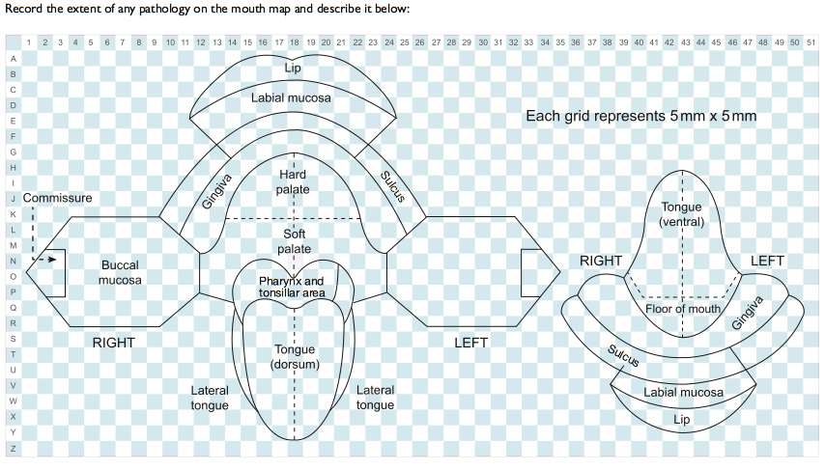
Further Description & Notes, including duration

